***C PROGRAM LAB TASK-7***

1. [**Write a C program to Store Information in Union and Display it**](https://techstudy.org/cLanguage/Write-a-C-program-to-Store-Information-in-Structure-and-Display-it)

**#include <stdio.h>**

**#include <string.h>**

**union student**

**{**

**char name[20];**

**char subject[20];**

**float percentage;**

**};**

**int main()**

**{**

**union student record1;**

**union student record2;**

**strcpy(record1.name, "Rajesh");**

**printf(" Name : %s \n", record1.name);**

**strcpy(record1.subject, "Maths");**

**printf(" Subject : %s \n", record1.subject);**

**record1.percentage = 86.50;**

**printf(" Percentage : %f \n\n", record1.percentage);**

**strcpy(record2.name, "Mani");**

**printf(" Name : %s \n", record2.name);**

**strcpy(record2.subject, "Physics");**

**printf(" Subject : %s \n", record2.subject);**

**record2.percentage = 99.50;**

**printf(" Percentage : %f \n", record2.percentage);**

**return 0;**

**}**

**Output:**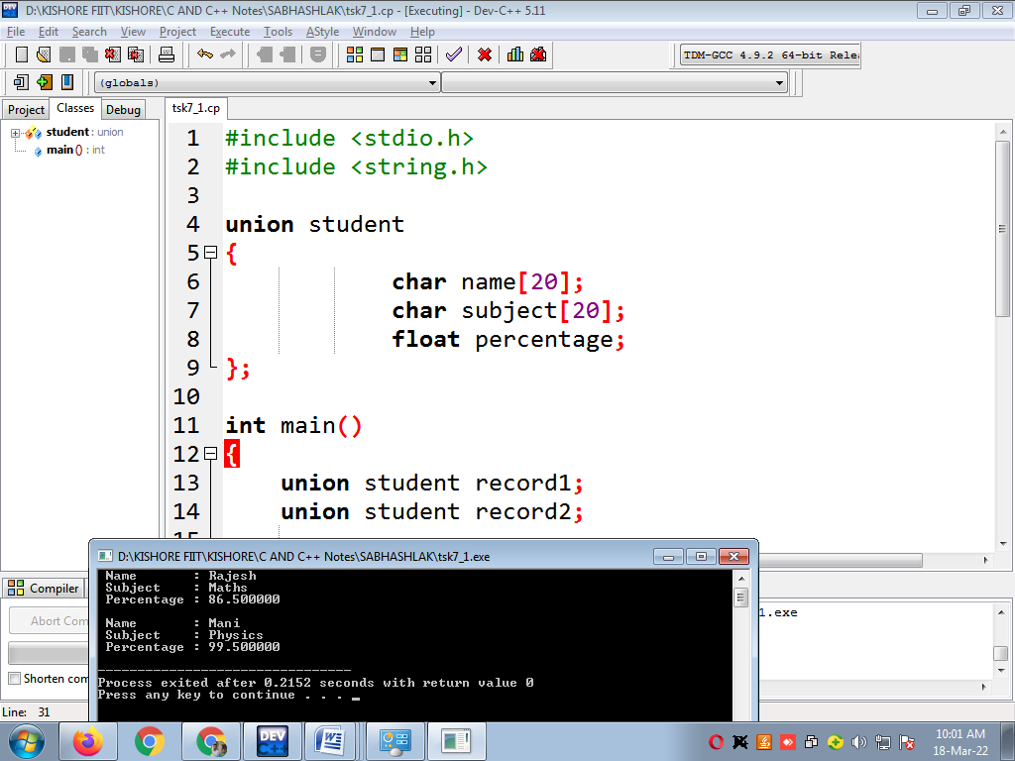

**2.** [**Write a C Program to add two distances in inch-feet system using Union**](https://techstudy.org/cLanguage/Write-a-C-program-to-add-two-distances-in-inch-feet-system-using-Structure)**?**

**#include <stdio.h>**

**union Distance {**

**int feet;**

**float inch;**

**} d1, d2, result;**

**int main() {**

**// take first distance input**

**printf("Enter 1st distance\n");**

**printf("Enter feet: ");**

**scanf("%d", &d1.feet);**

**printf("Enter inch: ");**

**scanf("%f", &d1.inch);**

**// take second distance input**

**printf("\nEnter 2nd distance\n");**

**printf("Enter feet: ");**

**scanf("%d", &d2.feet);**

**printf("Enter inch: ");**

**scanf("%f", &d2.inch);**

**// adding distances**

**result.feet = d1.feet + d2.feet;**

**result.inch = d1.inch + d2.inch;**

**// convert inches to feet if greater than 12**

**while (result.inch >= 12.0) {**

**result.inch = result.inch - 12.0;**

**++result.feet;**

**}**

**printf("\nSum of distances = %d\'-%.1f\"", result.feet, result.inch);**

**return 0;**

**}**

**Ouput:**

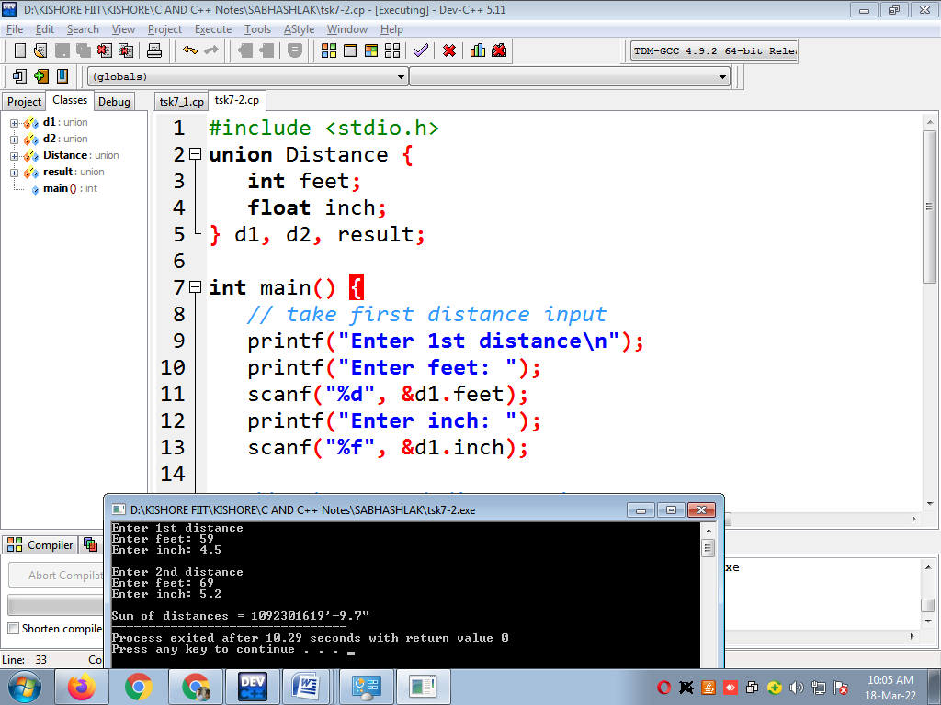

**3)** [**Write a C Program to Calculate Difference Between Two Time Periods**](https://techstudy.org/cLanguage/Write-a-C-program-to-Calculate-Difference-Between-Two-Time-Periods)**?**

**#include <stdio.h>**

**union TIME {**

**int seconds;**

**int minutes;**

**int hours;**

**};**

**void differenceBetweenTimePeriod(union TIME t1,**

**union TIME t2,**

**union TIME *diff);**

**int main() {**

**union TIME startTime, stopTime, diff;**

**printf("Enter the start time. \n");**

**printf("Enter hours, minutes and seconds: ");**

**scanf("%d %d %d", &startTime.hours,**

**&startTime.minutes,**

**&startTime.seconds);**

**printf("Enter the stop time. \n");**

**printf("Enter hours, minutes and seconds: ");**

**scanf("%d %d %d", &stopTime.hours,**

**&stopTime.minutes,**

**&stopTime.seconds);**

**// Difference between start and stop time**

**differenceBetweenTimePeriod(startTime, stopTime, &diff);**

**printf("\nTime Difference: %d:%d:%d - ", startTime.hours,**

**startTime.minutes,**

**startTime.seconds);**

**printf("%d:%d:%d ", stopTime.hours,**

**stopTime.minutes,**

**stopTime.seconds);**

**printf("= %d:%d:%d\n", diff.hours,**

**diff.minutes,**

**diff.seconds);**

**return 0;**

**}**

**// Computes difference between time periods**

**void differenceBetweenTimePeriod(union TIME start,**

**union TIME stop,**

**union TIME *diff) {**

**while (stop.seconds > start.seconds) {**

**--start.minutes;**

**start.seconds += 60;**

**}**

**diff->seconds = start.seconds - stop.seconds;**

**while (stop.minutes > start.minutes) {**

**--start.hours;**

**start.minutes += 60;**

**}**

**diff->minutes = start.minutes - stop.minutes;**

**diff->hours = start.hours - stop.hours;**

**}**

**Output:**

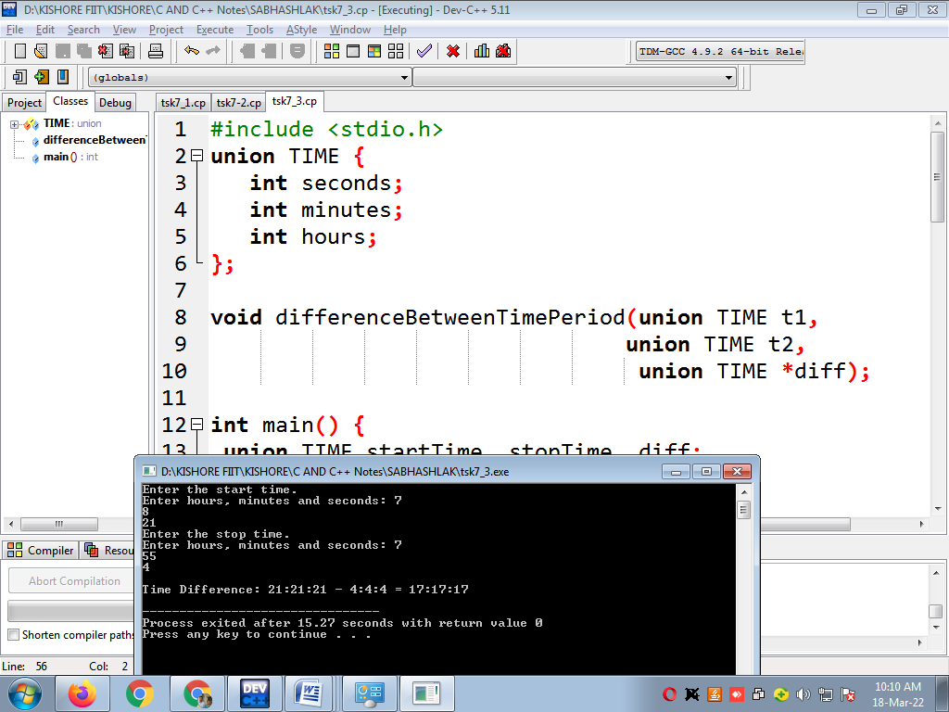

**4)** [**Write a C program to demonstrate example of Nested Union**](https://techstudy.org/cLanguage/Write-a-C-program-to-demonstrate-example-of-Nested-Structure)

**#include <stdio.h>**

**#include <malloc.h>**

**int main()**

**{**

**union A**

**{**

**long int y[5];**

**union B**

**{**

**double g;**

**union C**

**{**

**int k;**

**union D**

**{**

**char ch;**

**int x[5];**

**}s;**

**}a;**

**}b;**

**}*p;**

**p = (union A*) malloc(sizeof(union A));**

**p->b.a.k = 15;**

**printf("%d ,%d", p->b.a.s.x[0], p->y[0] );**

**return 0;**

**}**

**Output:**

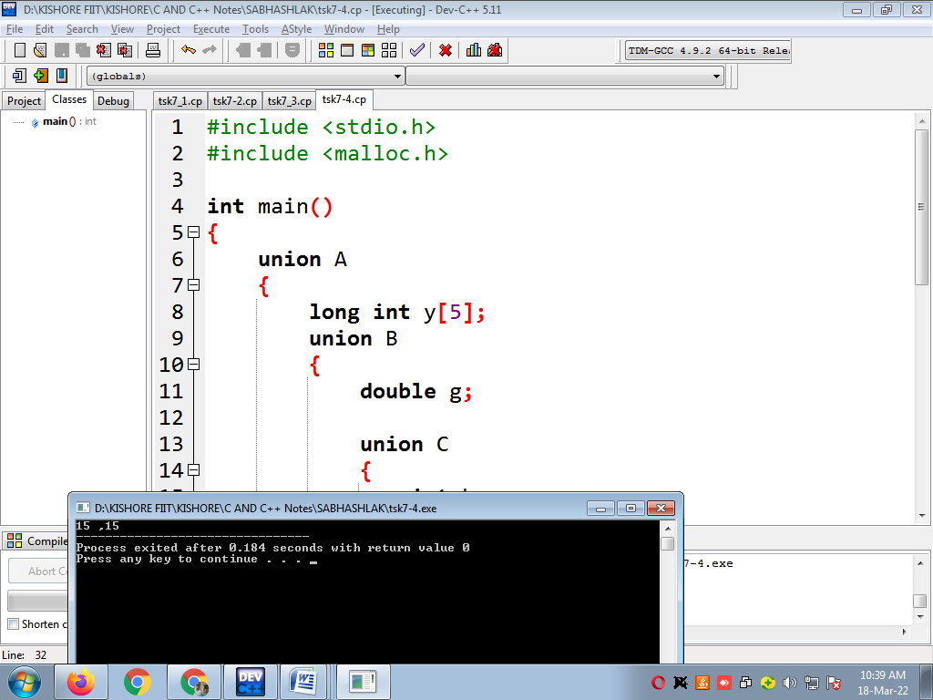

5. [Write a C program to demonstrate example of union pointer](https://techstudy.org/cLanguage/Write-a-C-program-to-demonstrate-example-of-structure-pointer)

**#include <stdio.h>**

**int main()**

**{**

**// union declaration**

**union number {**

**int a;**

**int b;**

**};**

**// union variable declaration**

**union number n = { 10 }; // a will be assigned with 10**

**// pointer to union**

**union number* ptr = &n;**

**printf("a = %d\n", ptr->a);**

**// changing the value of a**

**ptr->a = 20;**

**printf("a = %d\n", ptr->a);**

**// changing the value of b**

**ptr->b = 30;**

**printf("b = %d\n", ptr->b);**

**return 0;**

**}**

**Output:**

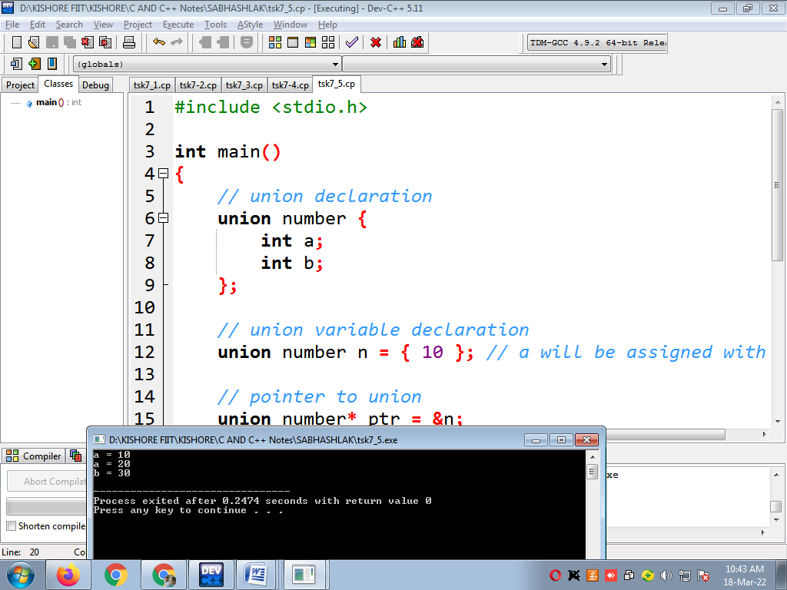

**6.** [**Write a C program to calculate percentage of student using union**](https://techstudy.org/cLanguage/Write-a-C-program-to-calculate-percentage-of-student-using-structure)**?**

**#include <stdio.h>**

**union Marks {**

**int roll_no;**

**char name[30];**

**float chem_marks, maths_marks, phy_marks;**

**};**

**//main function**

**int main() {**

**union Marks marks[5];**

**//Getting user input for info of the 5 students**

**for(int i=0; i<4; i++){**

**printf("Student %d\n",i+1);**

**printf("Enter roll no. :\n");**

**scanf("%d", &marks[i].roll_no);**

**printf("Enter name :\n");**

**scanf("%s",marks[i].name);**

**printf("Enter Chemistry marks :\n");**

**scanf("%f", &marks[i].chem_marks);**

**printf("Enter Maths marks :\n");**

**scanf("%f", &marks[i].maths_marks);**

**printf("Enter Physics marks :\n");**

**scanf("%f", &marks[i].phy_marks);**

**}**

**// Calculating and printing percentage for each student**

**for(int i=0; i<4; i++) {**

**printf("Student %d\n",i+1);**

**float percentage = (marks[i].chem_marks + marks[i].maths_marks + marks[i].phy_marks)/300.0*100;**

**printf("Percentage : %f\n", percentage);**

**}**

**return 0;**

**}**

**Output:**

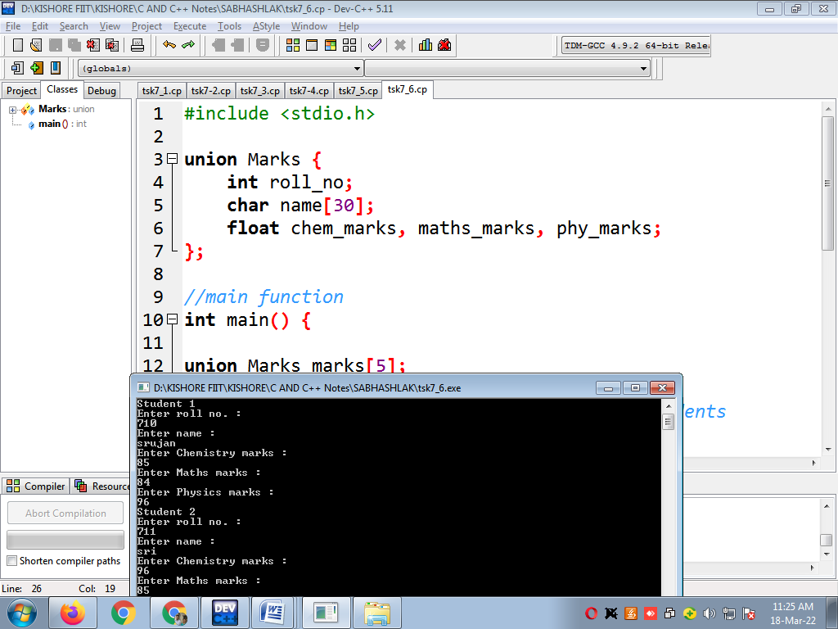

**7.** [**Write a C program to create Book Details using union**](https://techstudy.org/cLanguage/Write-a-C-program-to-create-Book-Details-using-structure)**?**

**#include<stdio.h>**

**#include<string.h>**

**#define SIZE 20**

**union bookdetail**

**{**

**char name[20];**

**char author[20];**

**int pages;**

**float price;**

**};**

**void output(union bookdetail v[],int n);**

**int main()**

**{**

**union bookdetail b[SIZE];**

**int num,i;**

**printf("Enter the Numbers of Books:");**

**scanf("%d",&num);**

**printf("\n");**

**for(i=0;i<num;i++)**

**{**

**printf("\t=:Book %d Detail:=\n",i+1);**

**printf("\nEnter the Book Name:\n");**

**scanf("%s",b[i].name);**

**printf("Enter the Author of Book:\n");**

**scanf("%s",b[i].author);**

**printf("Enter the Pages of Book:\n");**

**scanf("%d",&b[i].pages);**

**printf("Enter the Price of Book:\n");**

**scanf("%f",&b[i].price);**

**}**

**output(b,num);**

**return 0;**

**}**

**void output(union bookdetail v[],int n)**

**{**

**int i,t=1;**

**for(i=0;i<n;i++,t++)**

**{**

**printf("\n");**

**printf("Book No.%d\n",t);**

**printf("\t\tBook %d Name is=%s \n",t,v[i].name);**

**printf("\t\tBook %d Author is=%s \n",t,v[i].author);**

**printf("\t\tBook %d Pages is=%d \n",t,v[i].pages);**

**printf("\t\tBook %d Price is=%f \n",t,v[i].price);**

**printf("\n");**

**}**

**}**

**OUTPUT:**